# HW-3 – Relational Algebra

Database: Henry.rdb (WinRDBI database)

Use WinRDBI to create your relational algebra queries. For each question below, provide the text of your relational algebra queries (copy and paste the text), along with a screen image of the tuples in the final result. Submit your results as a Word document into Canvas.

*Remember that you must derive everything from the database, using only the values given in the questions. You may not look up a value manually and hard-code that into your query.*

1. List the author number and last name, the book code and title, for all authors who have written at least one non-paperback book.

q1author:=project authorNum , authorLast(author);

q1book:=select paperback='N'(book);

q1bookJoinAuthor:= wrote njoin q1book;

q1authorJoinbookJoinAuthor := q1author njoin q1bookJoinAuthor;

q1:=project authorNum,authorLast,bookCode,title(q1authorJoinbookJoinAuthor);

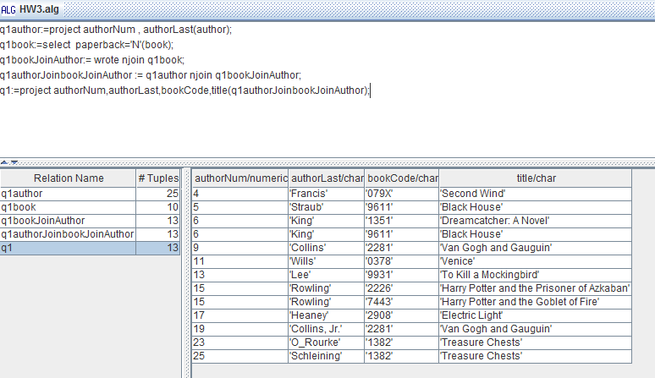

1. List author number and last name for all authors who have not written any books. (You must use the DIFFERENCE operator)

q2allAuthors:=project authorNum(author);

q2allwrittenBookAuthors:=project authorNum(wrote);

q2noWrittenBookAuthors:= q2allAuthors difference q2allwrittenBookAuthors;

q2 := project authorNum, authorLast(author njoin q2noWrittenBookAuthors) ;

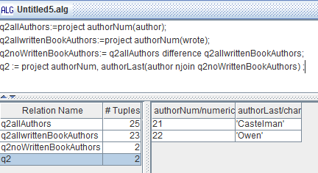

1. List the publisher code and publisher name for all publishers that have not published any books. (You must use the DIFFERENCE operator)

q3book:=project publisherCode(book);

q3publisher:=project publisherCode(publisher);

q3notPublishAnyBook:= q3publisher difference q3book ;

q3:=project publisherCode,publisherName(publisher njoin q3notPublishAnyBook);

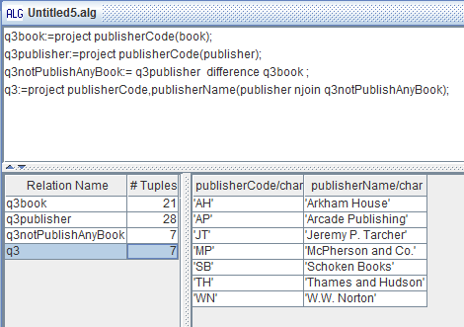

1. List the author number and last name, the book code and title, for all authors who have written at least one book that was published by Random House.

q4publisherCode:=project publisherCode(select publisherName='Random House'(publisher));

q4bookCode:=project bookCode(book njoin q4publisherCode);

q4book :=select bookCode=bookCode((select bookCode=bookCode(wrote njoin q4bookCode)) njoin book);

q4authorAndBook:=select authorNum=authorNum(q4book njoin author);

q4 := project authorNum,authorLast,bookCode,title(q4authorAndBook);

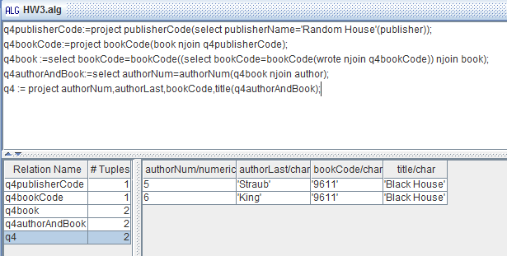

1. List publisher code and publisher name for all publishers who have published only paperback books.

q5paperbackYes:=project publisherCode(select paperback='Y'(book));

q5paperbackNo:=project publisherCode(select paperback='N'(book));

q5onlyYes:=q5paperbackYes difference q5paperbackNo;

q5 := project publisherCode, publisherName(q5onlyYes njoin publisher);

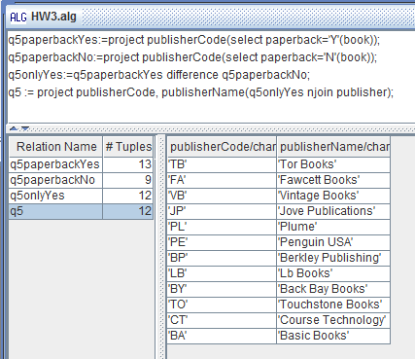

1. List the book code and title for all books for which there are more than one copy in the Henry Eastshore branch.

q6branchNum:=project branchNum(select branchName='Henry Eastshore'(branch));

q6inventoryGreatThan1:=select onHand > 1 (inventory njoin q6branchNum);

q6bookCode:=project bookCode(q6inventoryGreatThan1);

q6book:=select bookCode=bookCode(q6bookCode njoin book);

q6:=project bookCode, title(q6book);

